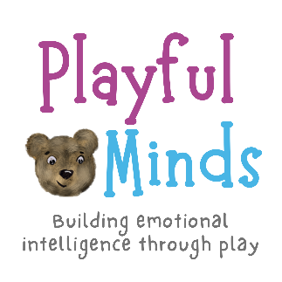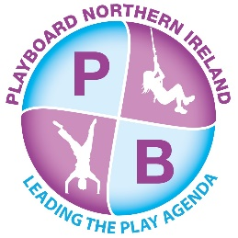

**Playful Minds: Building Emotional Intelligence through Play  
 Expression of Interest Form**

|  |  |
| --- | --- |
| **School/Setting Name:** | **Contact Name and Role:** |
| **Email:** | **Phone Number:** |
| **Is your school/setting a current member of PlayBoard NI?**  Yes  No | **Are you currently engaging with any other external programmes/ organisations?**  Yes No  **If yes, who is this with:** |
| **Number of children (ages 4-9) you would like to take part?**  **For schools, how many classes:** | **Proposed dates and times:**  Practitioner session 1: predelivery information (3hrs)  Practitioner session 2: post programme evaluation (1 hr)  Parents’ Stay and Play session (1hr) Children’s sessions (5x 2hr) |
| **Do you have suitable space for: indoor/outdoor**   1. Staff training sessions? 2. Children’s play sessions? | |
| **Please provide any additional comments or information about your setting that may be relevant:**  SEN support High number of children with English as an Additional Language (EAL)  Other | |

**Please return the completed form to the Playful Minds Team: PlayfulMinds@playboard.co.uk**